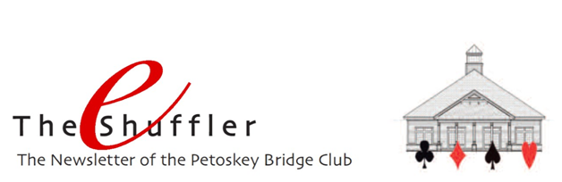

Happy Winter!!! The holidays are upon us. And our annual Christmas luncheon is too! Thursday December 13. 11:30 a.m. Sign up at the club to attend our fabulous luncheon and game to follow. $18 for the luncheon, wine included, and game. Pretty nice, eh!

Wintertime has also brought some changes to our game schedule. With many of our players off to their winter residences, we’ve revised our schedule. Notable in the revision is the addition of an Open section on Fridays, and the suspension of the Thursday evening game until Spring. The Thursday evening game continued this year for two months longer than previous years. Now, as expected, the attendance has dipped below the required minimum of 12 people. We hope to reinstate the game earlier in 2019 than in previous years.
Here are the details of our current wintertime schedule.
- Monday – no game
- Tuesday – Open section and 199er section. 12:30 game time.
- Wednesday – no game
- Thursday – Open section. 12:30 game time
- Thursday evening – Suspended until Spring.
- Friday – Open section; registration required by email. 199er section (no registration required). 12:30 p.m. game time.
- Sunday – no game

Winter Closing Policy - And since it is winter, please remember our Winter Closing Policy which is that we are closed when Petoskey's North Central Michigan College campus is closed.

Rank Progression - Congratulations to our members who have progressed in rank. Michele Widmer and Karen Edwards are new Junior Masters. Cammy Lowe, Larry Lutjens, and Ray Wieckert are new Club Masters. And Marcy Shuman is a new Sectional Master.

Zero Tolerance Policy - The holiday season is also a good time to remember how fortunate we are to have such a great group of players who come to our beautiful facility to play an amazing game together.

In appreciation of each other, let’s remember to “maintain a courteous attitude at all times” and to “carefully avoid any remark or extraneous action that might cause annoyance or embarrassment to another player or might interfere with the enjoyment of the game.” ACBL Law 74.

And please don’t argue with the Director. The Director’s ruling is final, and play must continue without further discussion or comment. An appeal can be filed at the end of the game if further clarification is required. Remember, the Director is responsible for implementing ACBL’s Zero Tolerance policy and “is empowered to assess disciplinary penalties in points or to suspend a player for the current session or any part thereof.” ACBL Law 91.

Let’s all commit to making sure that the atmosphere at our club is one in which all players can have an enjoyable time together.

Mike Sears Sez – Mike has covered lots of topics this past year. Balancing, sacrificing, claims, 8-card fits, playing in tempo, passing of boards, questions prior to the opening of play as well as during play, opening leads, carding and discarding, your Tool Kit (basic) and your Tool Kit (advanced), and when to call the Director among them. Hopefully they’ve been informative and helpful to you as you continue to hone your game. If you have a topic you’d like Mike to address in future eShufflers, please let us know.

Merry Christmas
Happy Hanukkah
&
Happy New Year

