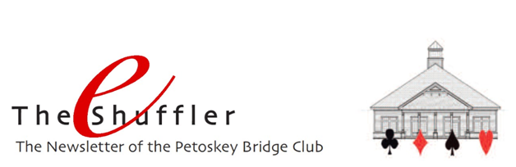

Winter is still here! And to let you know how much “winter” we’ve had, take a look at this picture! Sorry you missed it (if you did), but it’ll be gone soon.
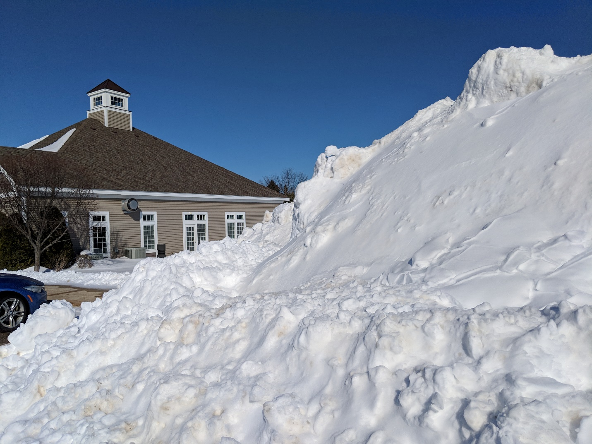

Spring/Summer Schedule and Game Fee – Our spring/summer schedule will resume on May 1. Yes, that is a Wednesday! Game time will be 10:00 a.m., and game fee will now be $9 for all games. Starting that Wednesday, the schedule will be:
Monday 10:00 am Open Game (All Players)
Tuesday 10:00 am Open section
199er separate section
Wednesday 10:00 am Open Game (All Players)
Thursday 10:00 am Open Game (All Players)
6:30 pm Open Game (All Players)
(registration required)
Friday 10:00 am Newcomers (Under 200 MPs)
Saturday Closed
Sunday 1:30 pm Open Game/Swiss (1/month)

(Note: Game time for the Tuesday April 30 game will be
12:30 pm.)

The Sunday games shown above will only happen if there is enough interest. You will receive an email about this next week.

Congratulations to Linda and Paul Dawson. They had an amazing 76.67% game on Friday March 22. How ‘bout that!!!
Congratulations to Betty Stephen and Carol Bertschinger for placing first in District 12 in the ACBL-wide Junior Fund game held January 22. They topped all competing players in the district with their 68.40% game that day. Their achievement is recognized on page 32 of the April Bridge Bulletin.

SPECIAL EVENT – Nationally acclaimed player, teacher and author LARRY COHEN is coming to Petoskey in JULY 2020! You’ve read his articles in the Bridge Bulletin. You may know that he’s won 25 National Bridge Tournaments, been named ACBL Honorary Member of the Year and ACBL Player of the Year. He’s authored award-winning bridge books, CD’s and software. And those who have had the opportunity to attend his seminars, bridge cruises and/or Regionals at Sea know the most important facts – he is a great teacher and genuinely kind person.
All we know at the moment are the basics. Larry will teach two days in July; they will be between 5 and 15 July. Each day will be composed of a morning and an afternoon lesson, each lesson followed by playing four hands that illustrate the concepts taught. The event is being co-hosted by the Birchwood, Walloon and Petoskey clubs and will be held at the Petoskey Bridge Club.
We’ll be sure to let you know once the dates are confirmed and details are worked out.
2019 Tournament Schedule – We’ll keep reminding you about the Unit’s tournaments this year:
- May 9-11 Grand Rapids Sectional
- May 31-June 2 Kalamazoo Sectional
- June 22-23 Petoskey Sectional for Future Life Masters
- August 19-25 Grand Rapids Regional
- September 6-8 Traverse City Sectional
- September 27-29 Petoskey Sectional
Click HERE for a complete listing of the District 12 tournaments for 2019.

2018 PBC Masterpoint Leaders - In January’s e-Shuffler we recognized our club members who placed in the top tier of ACBL’s Mini-McKenney and Ace of Clubs annual masterpoint races. Now, it’s time to celebrate members who won the most points at our club in each of our strats during 2018. In some cases, the points won moved players into a higher strat, but everyone is listed in the strat in which they began the year in January 2018. Leading masterpoint winners in each of the six strats were: Paul Nelson, Dave Fowler, Mason Rosenthal, Bob Giddings, Roy Sjoberg, and Balky Grannis. Congratulations to all!

Open Game Strats
A B C
1. Paul Nelson Dave Fowler Mason Rosenthal
2. Pam Ziegel Don Burkhardt Bob Hannah
3. John Kreag Betty Stephen Allison White
4. Carol Bertschinger Bernadette Burkhardt Barb Harbaugh
5. Geoff Goldich Clair Waterson Catherine Francis

199 Game Strats
A B C
1. Bob Giddings Roy Sjoberg Balky Grannis
2. Marsha Harrison Larry Shepherd John Warzecka
3. Peg Sjoberg Patti Grannis Linda Kerr
4. Mary Ann Voorheis Marlene Warzecka Jenny Armstrong
5. Bob Smith Madelon Weber Marsey Shuman

We celebrate the successes of these players, and their achievements challenge each of us as we move through this new year. We appreciate the fact that success in bridge is measured not just in masterpoints but in many ways - forming friendships, adding to our own skills and knowledge, enjoying our times together, appreciating each other. May this coming year be filled with many successes for us all. And thank you for playing at the Petoskey Bridge Club!

Unit of Record - When you choose to play at the Petoskey Bridge Club, you provide direct support to the club. We all appreciate how fortunate we are to have the club and our amazing facility where we gather to play regularly throughout the year. When you play at the club, you help us sustain our games, programs and facility. Thank you. It truly makes a difference.
Another way you can help is by making Unit 195 your Unit of Record. ACBL remits a portion of your annual dues to your Unit of Record, and the unit provides support to our club throughout the year. Even if you are not in Petoskey year-around, ACBL will still change your mailing address and you will still receive your Bridge Bulletin wherever you are.
Please contact Club and Member Services and request permanent Unit 195 affiliation. You can send an email to: masterpoints@acbl.org or send a letter to ACBL Club and Member Services, 6575 Windchase Blvd., Horn Lake, MS 38637. It may seem like a little thing, but as the saying goes, “Every little bit helps!” Thanks!

Mike Sears Sez – No topics were requested for this month, so Mike decided to spend the month in Florida with Debbie and the dogs. Let us know if you have a topic you’d like Mike to address.

In Memoriam – As reported last month, we’re sad to have lost Les Atchison. In his honor, his name has now been added to our In Memoriam plaque as a result of an anonymous donation of $1000 by his bridge-playing friends.

