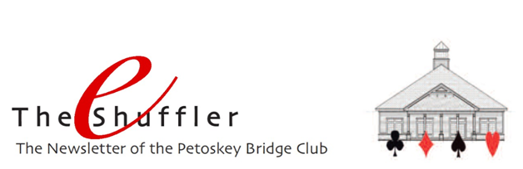
It’s December!!! And that usually means cold weather, snowfall, leftover turkey and, of course, it means that Christmas is right around the corner. We’re wishing each of you a safe and enjoyable holiday season with family and friends . . . and certainly lots of bridge!

Holiday Luncheon – Speaking of the holidays, be sure to put the annual holiday luncheon on your calendar. It’s Thursday December 12. Lunch time is 11:30 a.m. Game time is 12:30 p.m. Cost is $20. Please sign up at the club by Tuesday Dec 3 so we can have enough food for all.

Larry Cohen Seminar – We’re excited to have Larry Cohen, internationally-renown bridge champion and teacher, coming to our club to conduct a two-day seminar on July 13 & 14, 2020. It seems that you all are excited as well as the seminar sold out in just 9 days! For those of you who are interested in attending but do not have a reservation, please contact Allison White at allisonwhite49770@gmail.com to add your name to the waiting list.

Rank progression – Congratulations to our players who have progressed to the next level of rank:
- Junior Master - Patty Fralick
- Club Master - Grace Williams
- Sectional Master - Michelle Williams, Anne Saddison, Larry Shepherd, Kathy Snyder

Stumped for a gift? If you’re stumped for a gift this gift-giving season, Bridge Bucks is a great answer for your bridge-playing family members and friends. A Bridge Buck is a certificate which is redeemable at the club for one free play. It has no expiration date so whoever you give it to can play whenever they want. They’re available for purchase at the club. Cost is $9 for each. Ask the director.

Holiday schedule – What about our game on Tuesday Christmas Eve? Sorry, but no. The club will be closed. But we will be open for you to come celebrate Tuesday New Year’s Eve by playing with us at our usual 12:30 p.m. game time! Enjoy the holidays!

Tournaments –Click HERE for a complete listing of the District 12 tournaments. And be sure to add ours to your calendar . . . June 27-28, 2020 for the Future Life Master sectional and August 10-15, 2020 for the Petoskey Tip of the Mitt regional.

ALERT! A reminder of our winter closing policy: we’re closed when North Central Michigan College Petoskey campus is closed.

Find a Partner – Don’t forget that you can easily list yourself as needing a partner and look to see if any others have done so via the easy to use “Find a Partner” tab on our website.

Merry Christmas
And
Happy New Year!

