Greetings all. We're hoping that each of you is having a good winter, no matter where you might be spending it, and that you're ready to be in wonderful northern Michigan in a month or two or three. We're looking forward to seeing you all at the club.

It's not too early to get the two local tournaments on your calendar. The first one is our Future Life Master Sectional. It will be held at the clubhouse on Saturday-Sunday June 23-24. All those players who are not yet Life Masters and who have no more than 500 masterpoints as of June 1 are eligible to play. Linda Dawson is the chair (lindadawson555@gmail.com) and Allison White is handling partnerships (allisonwhite49770@gmail.com). The second is our Tip of the Mitt Regional, which we host every other year. Again this year, it will be held at the Odawa Casino. Opening session is Monday August 13, and it runs through Sunday August 19. Chair is Mike Sears (mmsears@sprynet.com) and Julie Kennedy will handle partnerships (tandjken@centurylink.net).

Speaking of tournaments, Joannie Henderson, Susan Trimble, Lynne Parker and Jonathan Friendly played at the Palmetto FL regional tournament the last week of February. On Saturday, they teamed up to play in the bracketed Swiss Team event. They cleaned up in their bracket, winning by a large margin and capturing 8.94 gold points. Congratulations! They look happy, don't they!

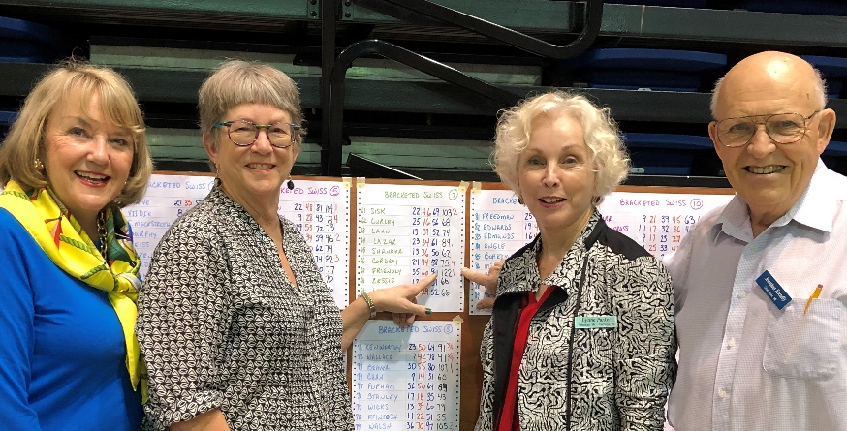

Mike Sears Sez - Tip of the Month - Balancing
So, you’d like to see your name higher on the list of results for today’s session. One tactic that should be in your toolkit to help make that happen is Balancing.
What is Balancing? Simply put, when you are in the pass out seat (i.e., if you pass, the auction is complete), to Balance is to not let the auction end by passing.
What are the circumstances when you should Balance versus when you should go ahead and pass out? To help visualize this concept, consider the following auction:
· N opens with 1D (convenient minor)
· E (your partner) passes
· S responds 1S (at least 4 Spades/at least 6 HCP)
· W (you) has a weak hand and passes
· N replies to S with a bid of 2S (4 Spades/no extra HCPs)
· E passes
· S passes (6-9 HCP)
· W (you) have to decide what to do
Based upon the auction so far, we know that N prefers diamonds to clubs for the convenient minor opening; we know that N has 4 spades; and we know that N does NOT possess extra values since he merely supported his partner’s 1S bid without jumping. We also know that S who promised 4+ spades and 6+ points has limited his point count to 9 or maybe 10 by passing N’s 2S bid. Bottom line is that we know that NS has a fit in spades and nominally 20 HCP. Hence, we also know that my partner and I (EW) also have nominally 20 HCP and likely have a fit in one of the other suits. When the hand is played, it is likely that NS will make 2S, scoring 110. It is also likely that EW can make 2 of something which, when they go set at the 3 level, will result in NS scoring either 50 or 100. Shall we let them score 110, or 50/100? I like the latter. Hence, in the auction above, rather than passing the hand out, W should bid his 5-card suit if he has one. If he does not have one, he should double asking partner to bid his longest suit. If after balancing, NS bids 3S, EW will always pass and let them play at the riskier, higher level.
So, if indeed the auction went this way, why would my partner (E) have passed initially following N 1D opening bid since he must have some HCP? Well, what if E had this hand:
· Xxx of spades, no honors
· Kx of hearts
· KJxx of diamonds
· AQxx of clubs
Following the opening bid of 1D, the best bid he can make is Pass. This is just an example of a hand which merits a Pass by E following an opening bid of any suit by N except hearts. (Note: If N had opened a H, E can make a takeout double, having support in all the unbid suits.)
Bottom line, if your opponents’ bidding shows a fit in a suit, and approximately only half the HCP (as I’ve discussed above), ALWAYS balance. The probabilities are heavily in your favor for a better board than if you don't.
Isn’t this a great game! Think!

Archived eShufflers - Hope you've enjoyed this month's eShuffler. All our previous ones are archived on the Petoskey Bridge Club's website. You can go there directly by clicking HERE.

