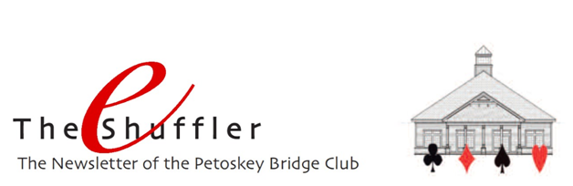

Happy summer everyone! Hope you’re enjoying the nice weather (finally!) and great bridge games at the club. Local traffic would tell us that lots of folks are in the area, as would our attendance this past month. We had 66 more tables of play this July than we had in July 2018. That’s more than a 20% increase! THANK YOU!!!

Welcome our new Game Director – Bob Smith has recently become a certified game director. Can’t have a game without a certified director, so having Bob available gives the club one more option to ensure we have someone to direct games.

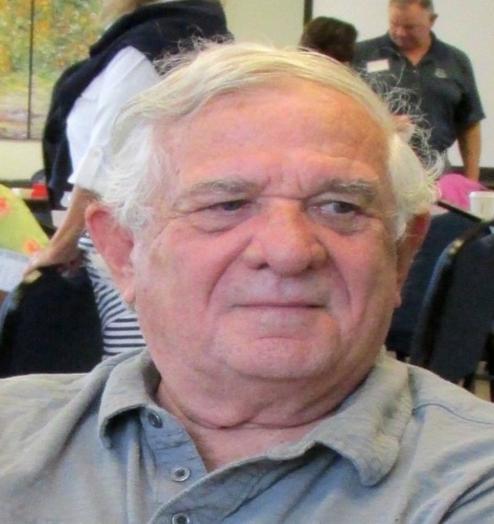

Congratulations, and thanks to Bob!
Petoskey Duplicate Bridge Center (PDBC) Corporation – The Petoskey Bridge Club is managed by the PDBC, which is a 501(c)(7) non-profit corporation. The corporation has a board of directors which is elected annually. At the recent annual meeting of the corporation, the following were elected as board members:
- Bernadette Burkhardt
- Linda Dawson
- Dave Deal
- Mike Sears
- Allison White
- Larry Willis
- Pam Ziegel

At the first meeting of this board, the board elected Mike Sears president, Pam Ziegel vice president, Dave Deal treasurer, and Bernadette Burkhardt secretary. Allison White serves as club manager, handling all the daily operations.

The board is pleased to report that the club is in good financial condition even though annual expenses exceeded annual income by approximately $2300. Major expenses included replacing our 10-year old chairs and expanding the parking lot. In addition, the board has successfully pursued a reduction in our future property taxes, which are a significant portion of our annual expenses.

Cell Phones Ringing – Congratulations! The silence of cell phones has been deafening! Since instituting a policy of matchpoint penalties for cell phones ringing, we’ve had only one instance of a violation. Thank you!!!

Rank progression – Congratulations to Diane Anderson who recently achieved the rank of Junior Master.

2019 Tournament Schedule – Here are the Unit’s upcoming tournaments this year:
• August 19-25 Grand Rapids Regional
• September 6-8 Traverse City Sectional
• September 27-29 Petoskey Sectional
Our sectional will be held at the Odawa Casino this year, so please note that on your calendar. We will also have 199er sections for all the events. Nancy Colbert is the tournament chair and Bob Smith is handling partnerships. Click HERE to see all the details.
Click HERE for a complete listing of the District 12 tournaments for 2019.

North American Pairs (NAP) Competition - Every summer, District 12 offers games in which players can qualify for the North American Pairs competition at a national tournament. We participate in those qualifications during the months of June, July and August. All games the weeks of August 5 & 26 will be qualifying events.

