Thanks! Yes, Thanksgiving is approaching, making it quite appropriate for us to give our thanks to:

- You the players for your continued play and support of the club.
- You the players who bring in snacks for all to enjoy.
- You the players for pushing in your chairs and clearing the snack tables of trash after each game.
- Jeannette Aspenleiter and Janice Smolinski for chairing the Hospitality committee (10th anniversary party, holiday party, regional reception, etc.), and Catherine Francis, Gloria Ferris, MaryAnn Voorheis, and Betty Stephen for their “always” help.
- Linda Roberts for her wonderful promotional material (how about those 10th anniversary boards!!!) and Jonathan Friendly as our unofficial “official” photographer.
- Jan Coltman for keeping our entrance attractive with her beautiful flowerpots.
- The kitchen cleanup team: Marsha Harrison (chair), Catherine Francis, Jan Coltman, Suzanne Sherk, Jan Haynes, Sally Stump, Kathy Snyder, Jeannette Aspenleiter, Janice Smolinski, Emmy Bade, and Cammy Lowe.
- Bob Giddings for regularly handling the trash and recyclables.
- Don Burkhardt and Paul Dawson for doing anything and everything that needs to be done.
- Our everyday directors Dale Thayer, Catherine Francis, Bob Smith, Nancy Colbert and Allison White for their commitment to the games we host (can’t have a game without a director!).
- Our summertime teachers Allison White, Bernadette Burkhardt, and Mike Sears.
- Our board of directors: Bernadette Burkardt (secretary), Dave Deal (treasurer), Linda Dawson, Larry Willis, Allison White, Pam Ziegel (VP), and Mike Sears (Pres).

Congratulations – Several of our players have moved up in rank:
New Junior Master – Debra Baker
New Club Master – Gordon Coffin, Laurie Marrs, Gerry Patten
New Regional Master – Gloria Ferris
New Silver Life Master – Joe Hollis
Congratulations to each of you!

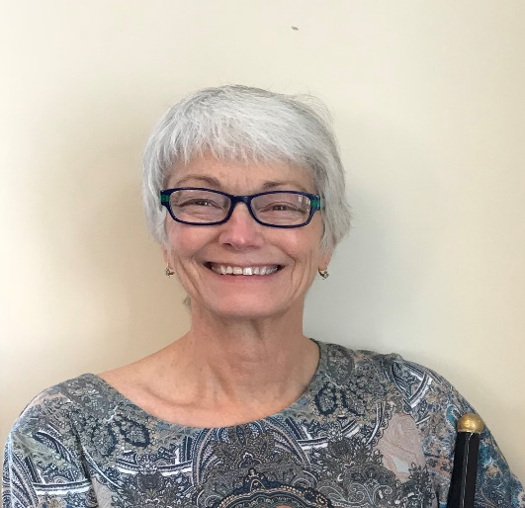
Goodwill Committee – And a special congratulations to Allison White who just recently was appointed to a lifetime membership in the ACBL’s Goodwill Committee by our district, District 12. The Goodwill Committee and its individual members work to create goodwill for ACBL. They receive, convey, and act on suggestions for the betterment of ACBL, particularly in the areas of active ethics, conduct, tournament conditions, bridge for Juniors, and bridge for the handicapped. The Goodwill Committee sponsors the ACBL's Active Ethics program, which educates ACBL members to the highest standards of conduct and propriety.
Congratulations, Allison! Quite an honor!

Tournaments –Click HERE for a complete listing of the District 12 tournaments. And be sure to add ours to your calendar . . . June 27-28, 2020 for the Future Life Master sectional and August 10-15, 2020 for the Petoskey Tip of the Mitt regional.

ALERT! Weekday game schedule – Just a reminder of our winter game schedule effective Friday Nov 1:
- Tuesday – Open game and 199er section.
- Thursday – Open game.
- Friday – Open game and 199er section.

Game time for each is 12:30 p.m.

ALERT! And a reminder of our winter closing policy: we’re closed when North Central Michigan College Petoskey campus is closed.

Find a Partner – Don’t forget that you can easily list yourself as needing a partner and look to see if any others have done so via the easy to use “Find a Partner” tab on our website.

