Here it is . . . November . . . and the club is still humming! Looks like a record number of tables is in the offing for the club in 2018. All our play days are still having healthy turnouts for this time of year. And the Thursday evening game continues into winter with sufficient play for a sanctioned game. Come join us. But not on Thanksgiving (nor the Friday following) as there will be no game those days. Happy Turkey Day!
Thanks to all of you for your continued support. We hope you’re enjoying the thought-provoking competition and camaraderie.

Hearts-Diamonds – Our most recent Hearts-Diamonds event took place on October 5. What a great event it was. 78 players enjoyed food, spirits and each other in our twice-a-year game in which our less experienced players are randomly paired with our more experienced players. A good time was had by all! Section winners were Susan Trimble/Christina Homan, Betty Stephen/Sandra Gay, Pat Grams/Barbara Lapham, and Barbie Claggett/Marlene Warzecha. Congratulations!

New Life Masters! Our heartiest congratulations to our newest Life Masters. Here are Barbie Claggett, Joe Hollis, Joanie Henderson and Carol Vial celebrating their achievement with a congratulatory cake at the club. Janie and Rick Richter have also recently become Life Masters. Congratulations to all!
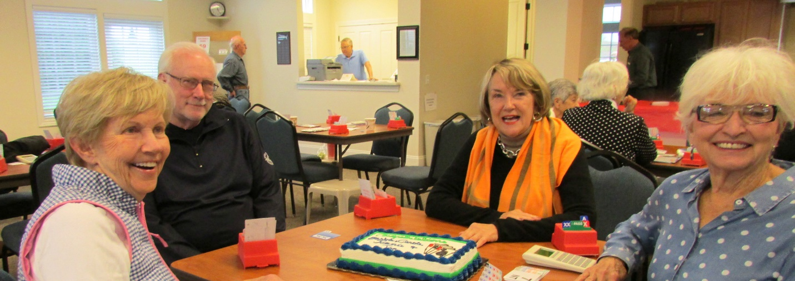

Rank Progression – Also moving up in rank are:
New Junior Master – Dave Prescott
New NABC Master – Jan Coltman and Susan Jackson
New Bronze Life Master – Barbie Claggett

Annual Christmas Luncheon – Yep, it’s nearly time for that deliciously fun Christmas luncheon and afternoon of bridge. Thursday December 13 at noon. Mark your calendar and plan to attend.
Do’s and Don’ts – It never hurts to remind ourselves of things we should do (and not do) at the bridge table:
- Do be a good host . . . and a good guest . . . at the table
- Do greet others with a friendly smile
- Do compliment opponents on good play
- Don’t be rude or intimidating
- Don’t criticize the play of your partner nor the opponents
- Don’t offer “lessons” during the game
- Don’t argue with the director
- Don’t turn your played card over until the winner of the trick has done so
- Don’t snap your cards when you play them
And how about when we are the Dummy:
- Do keep silent nearly all the time
- Do keep track of tricks won/lost
- Do ask Declarer (but not a defender) when he has failed to follow suit whether he has a card of the suit led
- Don’t draw attention to any irregularity during the play of the hand (you may do so when play is completed)
- Don’t participate in the play of the hand in any way
- Don’t remind Declarer from which hand he is to lead (unless it is apparent that he intends to lead from the wrong one)
- Don’t call the director

Mike Sears Sez - Preemptive Opening Bids – Preemptive bids are intended to take the bidding space away from our opponents. They can be very effective in preventing the opponents from entering the bidding and finding a contract which belongs to them. So, when you have a highly distributional hand with a long suit and a few high card points (approximately 6-10 HCP and a 6-, 7-, 8-card suit), go ahead and open with a bid of 2, 3, or 4, respectively.

There are two exceptions to making this bid that I recommend. One is when your long suit is very weak and your hand has tricks OUTSIDE your long suit. In those situations, wait to see how the auction proceeds and compete appropriately. The second exception is when you are in fourth seat and there are three passes ahead of you. As you can see, your opponents have already given up the bidding space that a preempt by you would take away. Hence, you should pass the hand out and take your good score on the board!

In Memoriam - We've recently lost one of members, Larry Burgess. He'll be missed. Our thoughts and prayers to his family.

