Game Schedule Changes – As we reported in the September eShuffler, there will be no more Sunday afternoon games until next Spring. And beginning with Monday Oct 1, all our daytime games will start at 12:30 p.m. Mark your calendars!

Hearts-Diamonds – Also mark your calendar for the next Hearts-Diamonds event. It's on Friday October 5 with a 12:00 noon start time. Hearts players will be those with 100 masterpoints or more; Diamonds, those with less than 100 masterpoints. Sign up at the club.

Game Directors – You can’t have a sanctioned game without having a certified director to conduct it. So, one of the issues we often deal with (no pun intended) is whether we have a director available to do just that. What do we do if Dale’s not available for some reason, or if Allison’s not available? Well, the good news is that we have a significant number of other folks we can call on if needed. Larry, Pam, Mark, Jonathan, Nancy and Mike are all certified directors, and they have all conducted games for us. And we now have two additional folks who are available to serve: Jan Coltman and Catherine Francis! Here’s a little bit about each of them and how they got into the bridge scene.

Jan Coltman – I started playing bridge while teaching English in Warren High School. We played 8 hands in 25 minutes during our lunch break. It was not very sophisticated, but it gave me a taste of the game until our little lunch group was split up due to declining enrollment.
When I retired from teaching, I played on the computer and freshened up my game to compete with the “old” ladies at the Community Center in Birmingham. There I learned what I didn’t know about the game…and I am still learning.

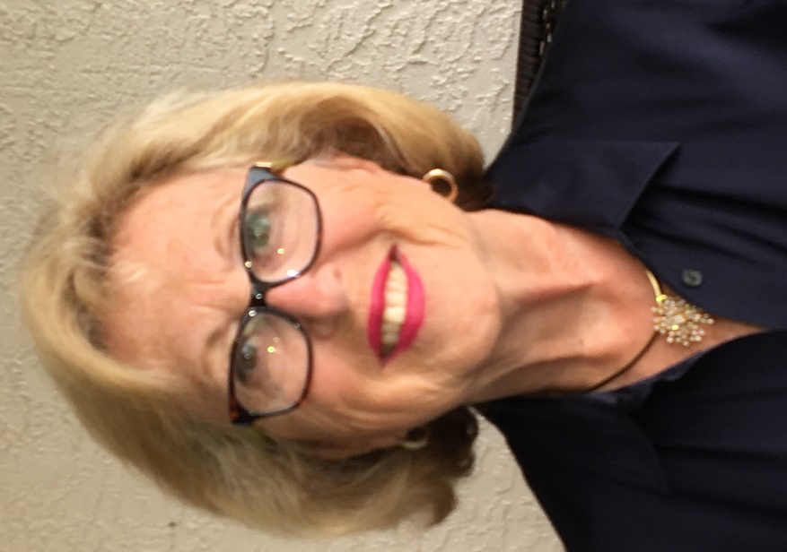
We moved to Charlevoix in 1999 and I played a little social bridge when I had time. I had started a business making drapes and various window treatments, and I was overwhelmed with the work. For a while, we owned a condo in the Naples area and there I took some bridge lessons, but still played rarely. It wasn’t until we sold our condo and decided that one home was enough that I became more involved in the game. I was tired of working and wanted to have some fun.

As I got more serious, I asked one of the senior players at the club to mentor me and help me to improve my game. That served to make me appreciate our club even more. It became a place where I made friends and found a challenge for my brain. My husband does not play the game, but even he has come to enjoy the friends we have made at the club.

One thing has led to another and I have decided to take on directing. This winter we are planning on spending the entire LONG COLD winter here in Northern Michigan and I know I will need the club and the people, each bringing a unique personality to the place. Our club is a wonderful place, with lots of generous people who volunteer their time. Directing is one way to help the club continue and succeed over the long haul. After all, it isn’t just a summer hang out…it functions all year long.

Catherine Francis - Having grown up on a lake downstate and summering at the family cottage on Torch Lake, I knew I wanted to retire in northern Michigan. After receiving a degree in art education from Michigan State University, I decided that a career in sales suited me better. I moved to Cincinnati to travel for Ralph Lauren and Calvin Klein Cosmetics. Relocating to Charlevoix in 1992 where I knew no one but my parents’ friends, I decided to learn how to play bridge as a way to meet people. Beginner bridge lessons were offered as an evening adult education option. From that exposure I moved on to running the long standing Charlevoix Hospital Guild Bridge group. I was then invited to “kibitz “ the duplicate group playing in Petoskey. That led to playing regularly at our outstanding bridge club. Becoming a director was not on my radar at all, but when approached by Larry Willis, I decided it would be a way to give back to this wonderful club that has exposed me to so many lovely people that have become great friends and opened so many doors to the community that I would otherwise not have experienced.

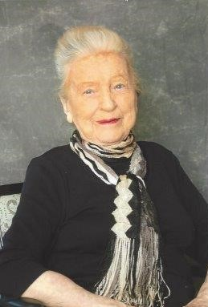
Golden Age Master – Another of our long-time players, Audrey Rigg, has recently been awarded the title of Golden Age Master by the ACBL. Congratulations Audrey!

Rank Progression – Several of our players have recently progressed in rank. They are:
- Junior master - Carra Schoene
- Sectional master - Bob Eaton
- Ruby life master - Bill Trimble
Congratulations to all of you!

Mike Sears Sez – As many of you know, this summer we’ve been doing mini-lessons on Tuesdays prior to the game. One aspect of bidding that has come up frequently at these sessions is the importance of finding the 8-card major suit fit. While this is readily apparent to Responder if Opener opens with a major, and readily apparent to Opener if Responder overcalls a major, there are many other instances where things are not so apparent. The Negative Double, Support Double and New Minor Forcing convention are tools to help solve this dilemma.

Negative Double – The Negative Double comes into play when Opener bids a minor, his LHO overcalls a suit, and Responder wants to show a 4-card major. Since an overcall by Responder would show a 5-card suit and thus is not an appropriate bid, he could use the Negative Double to show a 4-card major. Click HERE to “read all about it.”

Support Double – The Support Double comes into play when Opener wants to show 3-card support for his partner’s bid suit. An example auction might explain this more simply:
- North opens 1D
- East passes
- South bids 1H
- West bids 1S
- North has 3 hearts in support of South’s hearts. This is where a double would show his 3-card support for Responder’s bid of 1H, hence the term Support Double. (Note: If North had 4 hearts, he would bid 2H over West’s bid of 1S.)
You can read more about Support Doubles by clicking HERE.

New Minor Forcing – Another situation that occurs frequently is when Responder bids 1H/S following Opener’s minor suit opening, and Opener bids 1NT (no extra values and not 4 cards in Responder’s bid suit). When Responder has 5 cards in his bid suit, he’d like to show it. He can do so with the use of this convention by bidding 2 of the unbid minor. This promises not only that he has 5 of his major suit but also a good 10 or more HCP. This convention is more fully explained HERE.

In Memoriam - We've recently lost one of members, Cheryl Lawton. She'll be missed. Our thoughts and prayers to her family.

