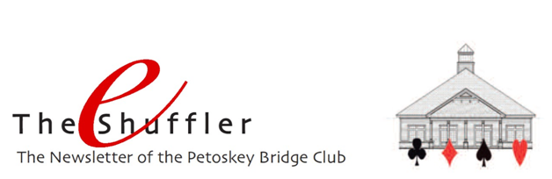
Happy New Year! We’re looking forward to another year of fellowship and challenging bridge, and we hope you are too. It should be exciting, especially this summer when we conduct our annual Future Life Master tournament in June, sponsor Larry Cohen’s seminar in July, and host the unit’s Tip of the Mitt regional in August.

How about 2019!!! Yes, it’s behind us, but what a year. Thanks to all of you, we set an all-time record for table plays at the club. 2359.5 tables! That exceeds our previous high of 2292 tables in 2015 and places us as the second largest bridge club in the state (the Bridge Connection in Southfield is the largest with over 6000 tables of play). Truthfully, that’s pretty amazing.

Larry Cohen Seminar –Even though we are sold out for Larry’s seminar on July 13 & 14, 2020, we are maintaining a wait list. Contact Allison White at allisonwhite49770@gmail.com if you’d like to add your name.

Rank progression – Congratulations to our players moving up in the ranks:
- New club master - Bob Goebel
- New sectional master - Tina Raine, Sally Stevens, Carol Stroud
- New life master - Mason Rosenthal
- New bronze life - Nancy Colbert, Mason Rosenthal

Tournaments –Click HERE for a complete listing of the District 12 tournaments. And be sure to add ours to your calendar . . . June 27-28, 2020 for the Future Life Master sectional and August 10-15, 2020 for the Petoskey Tip of the Mitt regional.

In Memoriam – Sadly, we’ve lost a long-time player and friend, Roger Wolthius. Our thoughts are with his family and friends.

ALERT! A reminder of our winter closing policy: we’re closed when North Central Michigan College Petoskey campus is closed.

Find a Partner – Don’t forget that you can easily list yourself as needing a partner and look to see if any others have done so via the easy to use “Find a Partner” tab on our website.

Happy New Year!

