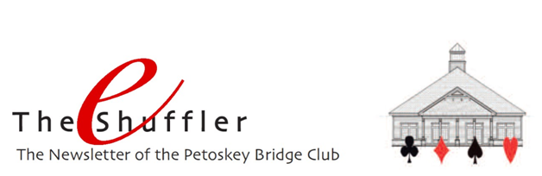

The Bridge House - Yep, in keeping with national guidance to minimize the spread of the Coronavirus and help keep our members safe, we remain closed. Hopefully each of you is well and continuing the needed safety precautions to stay that way. When will we re-open? Time will tell. We’ll pay close attention to Federal, state, and local officials, to ACBL for guidance, and to the COVID19 data re: new cases in our area.

Tournaments and Events – As you know, many Michigan tournaments and events have been canceled, including Traverse City’s National Cherry Festival and Charlevoix’s Venetian Festival. We’ve been informed that virtual clubs will not be permitted to conduct sectionals or regionals. Hence, we have canceled both our FLM (June 27-28) and our regional (August 10-15). Good news, our unit has agreed to our hosting a regional in Petoskey next summer. It will be held August 11-16, 2021 at the casino.

BBOPetoskey – While we can’t play with each other at the Bridge House, we can play and are now playing together online! With the initial hard work of Allison White, Nancy Colbert, Larry Willis, and Mike Sears, our Virtual Club games are up and running. Going forward, we welcome Sally Stevens and Josie Doherty as additional game directors.
You have supported our regularly scheduled games on Tuesday and Friday with extraordinary participation. Since our first game, we have been averaging 24 tables/day between the two games. That is the highest in the state!!! Thank you sooooo much. It’s keeping us financially afloat.

It’s often beneficial if our directors can reach you to try to solve issues immediately prior to and during the game. We ask you to check your MyACBL account on ACBL.org to be sure that the phone number and email address are current as that information is available to the directors to contact you.

Results for our Virtual Games – There are a variety of ways to get the results from your playing in our virtual games, about an hour after the game finishes.
BBO – when logged in to BBO, you can select the history tab and then the game you want to see the results for. It will show you where you finished, and with a little work, you can see the travelers and the hand records for that game. You can also see the bidding, and the play of each card to each trick.
PBC Website – you can go to the PBC website homepage and click on BBO Results. Rankings and travelers are available.
ACBL Live – ACBL will email results to you if you have an email address in your account. Rankings and travelers are provided.
The Common Game (TCG) – Now that we are using TCG boards in our virtual games (as we do at the bridge house), you will get an email with results and hand records for all hands if you are signed up with TCG. To do so, simply send an email to: FastResultsHelpDesk@gmail.com with your ACBL # in the subject line (no message needed).

Find a Partner/BBO Usernames – The Find a Partner tab on the website continues to be a nice vehicle to let folks know you are looking for a partner. In addition, BBO Usernames have been added to the Roster so you can see who is playing online and contact them directly for a partnership. If you have a Username and it’s not listed, please send it to us and we’ll add it.

A second option is to log-in to BBO when registration for our game begins, two hours before game time, and follow the same steps you would if you were registering. However, when you reach the registration page with the blue box, go to the top of the page, find Partnership Desk and enter your name. Or, if someone else’s name is already there, contact/invite them to be your partner. Be sure to remove your name once you have a partner.

Non-Profit Corporation Annual Meeting – As you know, the Petoskey Duplicate Bridge Center (aka Petoskey Bridge Club) is a non-profit corporation run by a board of directors. Members of the corporation pay an annual fee of $50 which entitles them to attend the corporation’s annual meeting and to elect the members of the board of directors. If you would like to be a member of the corporation, and you are an ACBL member, you may do so by sending a check payable to Petoskey Bridge Club and mailing it to P.O. Box 722, Petoskey, MI 49770 prior to July 1. The corporation’s annual meeting this year will be held on Wednesday, July 8.

You do not have to be a member of the corporation to play bridge at the club or online. All who play at the club and online are considered members of the club.

