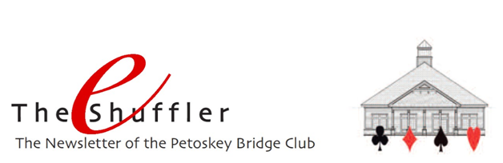

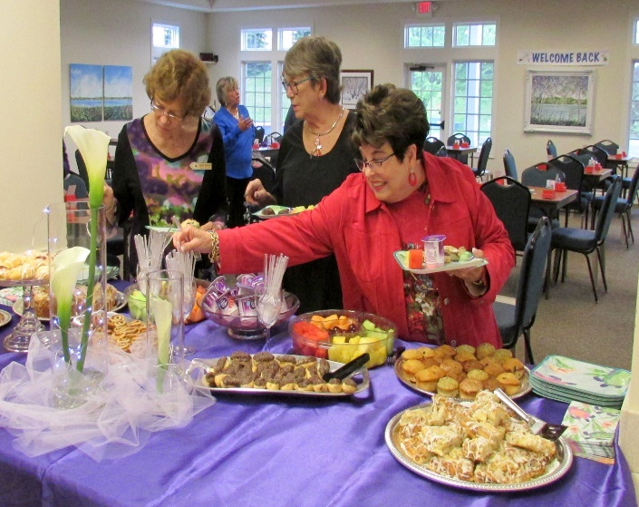
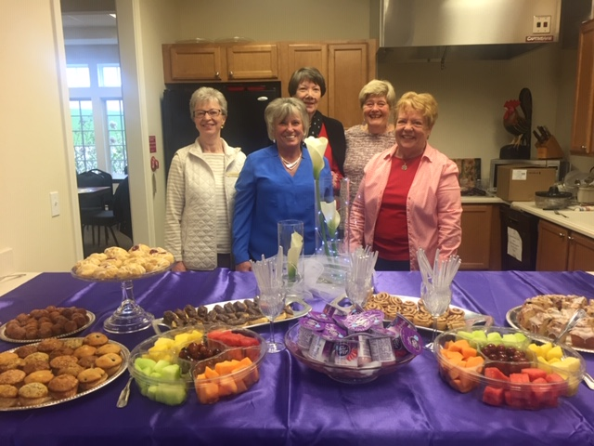
Welcome Back!!! And what a nice welcome back day it was, that Tuesday June 4th. Seventy players came and enjoyed the continental breakfast, meeting and re-meeting friends, and an excellent game of bridge. Our thanks to our hospitality committee (Catherine Francis, Janice Smolinski, Mary Ann Voorheis, Jeannette Aspenleiter, Grace Williams) for organizing the breakfast, and for all who attended (Kathy Henricks, Susan Trimble and Carra Schoene shown) for coming to enjoy the day.

Future Life Master (FLM) Sectional Tournament, June 22/23 – Our FLM tournament drew 184 participants from far and wide. From as far south as Trenton, as far north as the UP, and locally from Petoskey, Antrim County, Walloon Lake and Birchwood, players came to compete to win silver points at our annual event. Congratulations to our winning pairs and team, and a very much deserved THANKS to our tournament chair Linda Dawson!

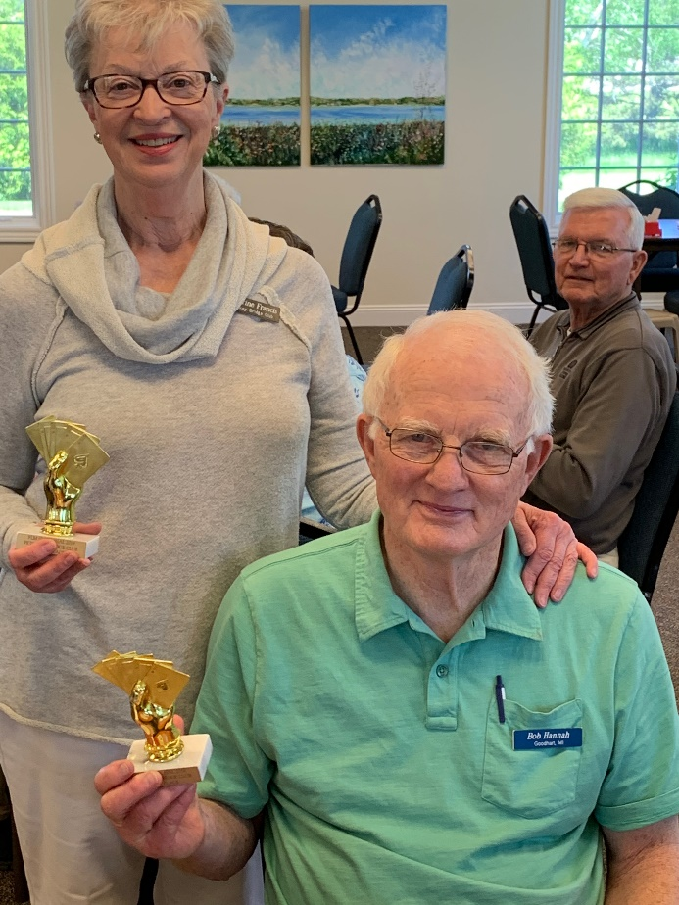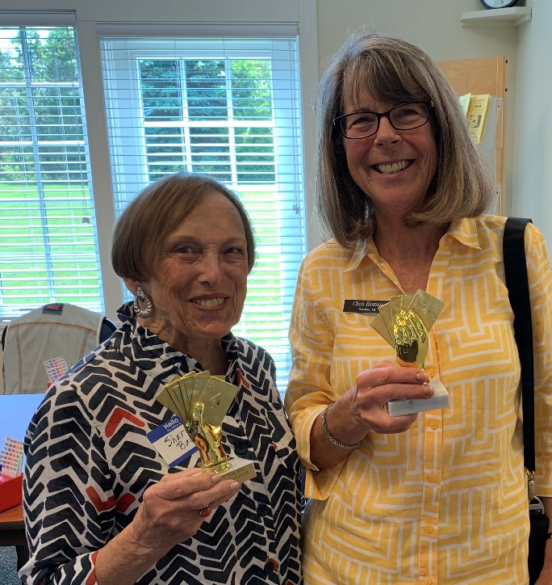

Catherine Francis and Bob Hannah, and Sharon Bacon and Chris Homan took honors in the Saturday morning session.

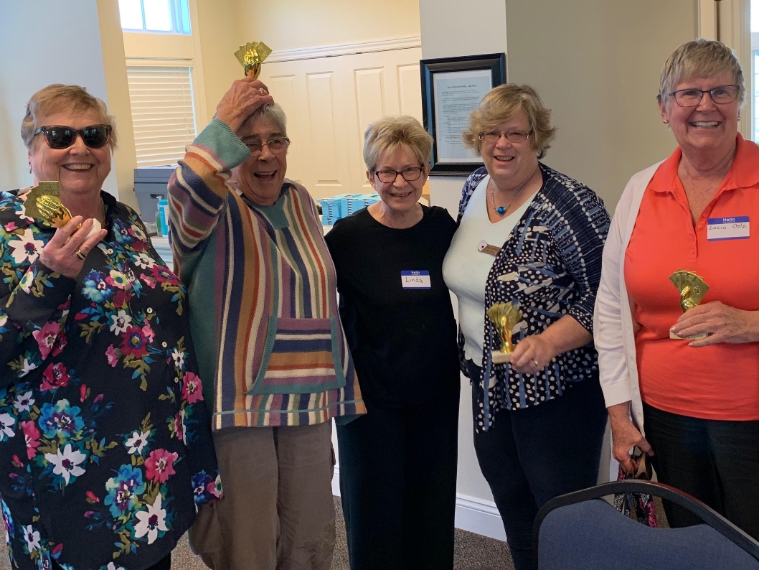

In the afternoon, Carol Pressman, Louise Haley, Anne Allison and Lucia Oelz took first place honors and celebrate here with tournament chair Linda Dawson.

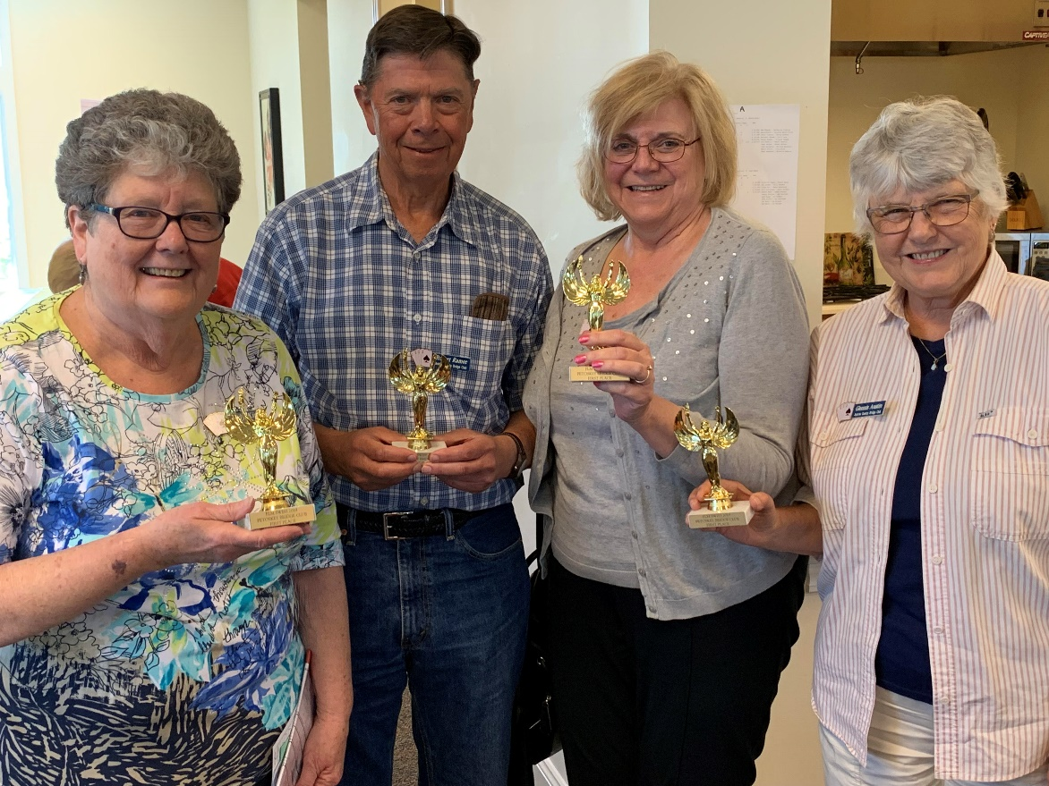

Judy King, Robert Ramee, Sandy Ramee, and Glennis Austin came in first place in the Sunday Swiss team event.

Celebration and Farewell to Bob Kazmierowski
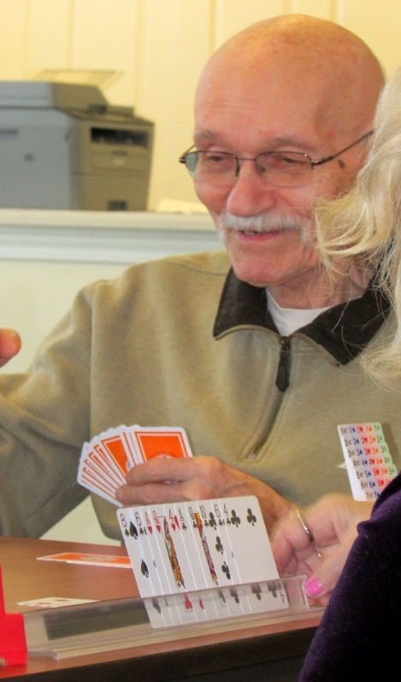
On Monday, May 13, Kathy Henricks & Marsha Harrison organized a celebration for Bob Kazmierowski. It was a celebration of his ardent love for the game of bridge. Chocolate covered cream puffs and veggie pickle ham rollups were a special treat that morning.

Bob began and directed a game in Cheboygan for 40 years. He also drove 3-4 times a week to many games in Harbor Springs and then across the bay where he and his wife, Toni, were generous donors for our new Petoskey Bridge Club. Bob enjoyed his vehicles and sports, wearing apparel featuring a Red Corvette, Black Escalade, Blue Lions, Harley Motorcycle, or Spartan Green. Years ago, he and his partner flew to a national CA tournament, picked up another pair and came home with 40 gold points! Next came his red, silver, and black points. Kaz usually arrived early at the games reading the sports page of the Detroit Free Press. As players arrived, Kaz would give the daily quiz questions to anyone who dared!

Bob will be remembered for his deep, throaty laugh, as well as vocal intensity at times! He was within 30 points of becoming a Silver Life Master. However, for the last 2+ years, his life has taken a new path. While bidding the hand became very difficult, he could still count the cards as declarer (the CPA in him!). We will miss him.

Lessons – What a great turnout for our free lessons this summer. Ninety players are participating in the Learn to Play and the Defensive Strategies lessons. Allison White and Bernadette Burkhardt are once again leading the team in the organization and teaching of the lessons. Weekly guest teachers continue the effort by volunteering their time for a week’s worth of lessons. Here are Pam Ziegel, Debbie Deal and Nancy Colbert leading the classes.

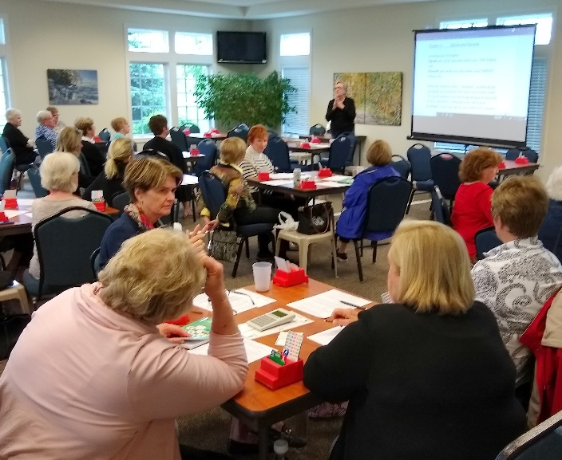
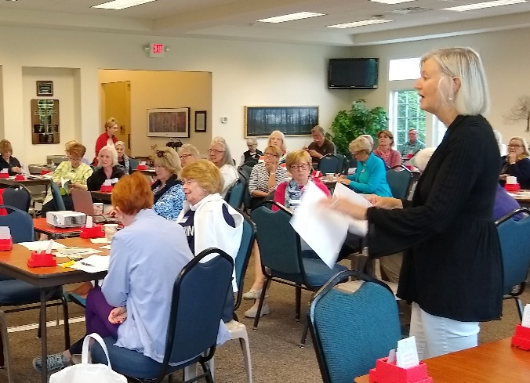
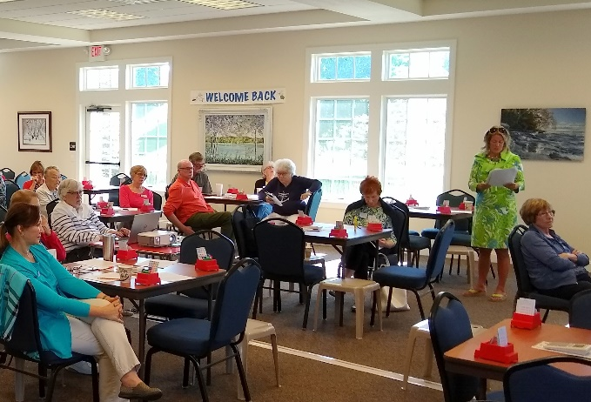

2019 Tournament Schedule – Here are the Unit’s upcoming tournaments this year:
• August 19-25 Grand Rapids Regional
• September 6-8 Traverse City Sectional
• September 27-29 Petoskey Sectional (held at the Odawa Casino)
Click HERE for a complete listing of the District 12 tournaments for 2019.

North American Pairs (NAP) Competition - Every summer, District 12 offers games in which players can qualify for the North American Pairs competition at a national tournament. We participate in those qualification events during the months of June, July and August. All games the weeks of July 8 & 22, and August 5 & 26 will be qualifying events.

Petoskey Duplicate Bridge Center (PDBC) Corporation - The Petoskey Duplicate Bridge Center (PDBC) is a 501(c)(7) non-profit corporation. Membership dues is $50 annually and due prior to July 1. Members of the corporation may attend its annual meeting, which will be held this year on Wednesday, July 10, 2019. The board of directors is elected at this meeting.

The Petoskey Bridge Club is managed by the corporation. All who play bridge at the Petoskey Bridge Club are considered members of the club. No membership fee is required.

