

**Congratulations!** Another outstanding job done by bridge club volunteers hosting the recent Unit 195 Regional tournament. While attendance was down slightly from 2016, it was still a great turnout. Five hundred forty-five different players participated, winning 5,375 masterpoints! ACBL president Jay Whipple attended for much of the week. District 12 Director and Unit president Dennis Carman spent the entire week with us. Many professional players and teams participated. Petoskey is a destination that bridge players love to come to and spend some time. And the casino is a great venue with good access and plenty of playing space to spread out and be comfortable while playing. We expected a great turnout, and it was!

And speaking of winning masterpoints, three of our club players won enough points at the tournament to become Life Masters. Joanie Henderson, Barbie Claggett and Joe Hollis all achieved that coveted rank. In fact, almost all of our club players who participated won some points. Here’s the list of those who won at least 10 masterpoints:

* Susan Trimble - 39.74
* Bill Trimble - 29.96
* Betty Stephen - 28.29
* Mark Hess - 24.22
* Debbie Deal - 21.15
* Dave Deal - 21.15
* Geoff Goldich - 21.07
* Jonathan Friendly - 19.27
* Nancy Colbert - 18.80
* Joe Hollis – 18.18
* Julie Kennedy - 17.28
* Tom Kennedy - 17.28
* Joan Henderson - 14.71
* Dave Fowler - 14.65
* Pam Ziegel - 14.14
* Bernadette Burkhardt - 13.27
* Don Burhardt - 13.27
* Dierdre Laveran - 12.72
* Lulie Eide - 12.55
* Jim Burt - 11.57
* Peter Cullman - 11.39
* Karen Abbott-Quigley - 11.39
* Barbie Claggett - 11.14
* Pandy Huff - 10.43
* Melissa Georges - 10.02

And if we think that bridge tournaments are about winning masterpoints, how about Julie Kennedy’s story about chairing the Partnership desk:

Most players want points when they attend a regional; however, as the Partnership Chair of the Petoskey Regional I found some nifty “perks” during the week. A pair thanked me for arranging their partnership because they won their session - WOW.

Later, another player also thanked me for her match-up which lasted through much of week. She was a guest to our club and after an evening Swiss was not looking forward to the late drive home to Charlevoix.  Her partner kindly offered to share her double room at the event hotel.  The next night after bridge she invited her partner and their teammates to her home in Charlevoix for cocktails and tour of this beautiful lakeside city - FRIENDSHIPS MADE.

On the last day at the Swiss game, one pair did not show. With last minute scrambling another pair was found and they won 5 gold - COOPERATION.

It was hectic at times developing partnerships for over 60 people because some partnerships “broke up” during the week due to illness or emergencies back home. I certainly couldn’t have managed it without the great volunteers that helped me - HELPFUL.

Bridge can be many different things and these PERKS and many thanks from club members and new partnerships made this week totally WORTHWHILE.

Thanks and congratulations to all once more. Job well done!

**Rank Progression –** Several of our players have also recently progressed in rank. They are:

* New Junior Master - Sue Blevins, Jane Horn
* New Club Master - Michelle Robbins, Anna Saddison
* New Sectional Master - Jim Apostolakis, Frances Borchers, Tom Daly, Sandra Gay, Balky Grannis, Linda Kerr
* Life Master - Ginny Braidwood, Jonathan Friendly

Congratulations to all of you!

**Game Schedule Changes** – The season is changing, which means many of our seasonal players are departing, which means it’s time for us to make some game schedule adjustments. For starters, there will be no more **Sunday afternoon** games until next Spring. We’ll continue with **Thursday evening** games for as long as at least 3 tables (6 pairs) sign up in advance through our email registration process. And beginning with **Monday Oct 1,** all our daytime games will start at 12:30 p.m. Mark your calendars!

Also mark your calendar for the next Hearts-Diamonds event.  It's on Friday October 5 with a 12:00 noon start time.  Hearts players will be those with 100 masterpoints or more;  Diamonds those with less than 100 masterpoints.

**Memorial Fund** - The club has received inquiries regarding a desire to recognize players who have had an impact on the club but are no longer with us.   As a result of those inquiries, we have established a**Memorial** **Fund** so that donations may be made in their honor.   The fund will be held separate from general operating funds, and would only be used for future major improvements.  We will maintain a plaque prominently displayed in the club house that lists the names of those honored.  While a donation to the club of any amount is always appreciated, a minimum donation of $1000 by one or more persons to honor one of our deceased players would result in the player's name being added to the plaque.  (Note that, although the club is a non-profit corporation, it is not a 501(c)3 and therefore donations are not tax deductible.)

**Golden Age Master –** One of our beloved founders has recently been awarded the title of Golden Age Master by the ACBL. Shirley Carpenter was presented the certificate designating her as such by our club president Larry Willis.

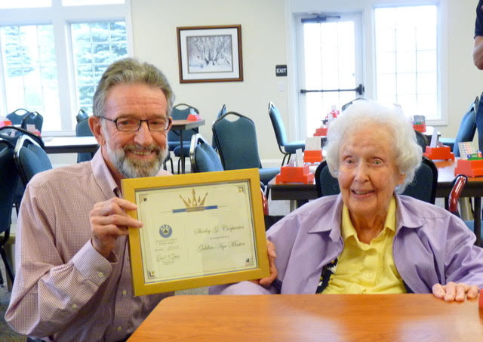

Long time club players Nancy Fowler and Adele Sjoberg were also awarded the Golden Age Master title. Congratulations to all!

