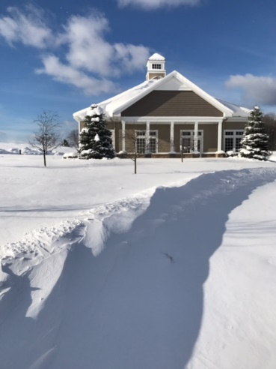
Winter is upon us! It’s cold outside. And it was cold inside as one of our two furnaces decided to call it quits. Good news is that we’ve replaced it with a new one and the bridge house is once again warm and cozy. So come on over and enjoy friends and bridge every Tuesday, Thursday and Friday.

2019 Masterpoint Races – With the year complete, ACBL’s annual masterpoint races have been finalized. There are two. One is the Ace of Clubs competition in which the number of masterpoints won at club games determines the winners. The second is the Mini-McKenney competition which includes masterpoints won at tournaments in addition to those won at clubs. Recognition of players is made in accordance with the unit in which they reside. Most of our players reside in either Unit 195 (all of western MI) or in Unit 200 (eastern MI north of the greater Detroit area). And did our players ever do well!!! Here are the players who finished in the top 10 in their respective category:
Mini-Mckenney Competition (grouped by masterpoints held at the beginning of the year):
0-5 Robert Hawkins 1st
5-20 Gay Grafinger 4th
Sheryl Kendrick 7th (unit 200)
Celine Johncox 9th
20-50 Christina Homan 4th
50-100 Anne Cummins 3rd (unit 200)
Jim Cummins 3rd (unit 200)
Marlene Warzecha 4th
John Warzecha 5th
Linda Kerr 8th
Gloria Ferris 9th
100-200 Peg Sjoberg 6th (unit 200)
Roy Sjoberg 6th (unit 200)
200-300 Jan Coltman 6th
Dale Thayer 7th (unit 200)
300-500 Bob Hannah 7th
500-1000 Eva Walker 9th (unit 200)
John Hastie 9th (unit 200)
1000-1500 Mark Hess 10th

Most of the players above also placed in the Ace of Clubs competition. Those not recognized above but who placed in the top 10 in their Ace of Clubs category include:

5-20 Robin Ellis 4th (unit 200)
50-100 Patty Grannis 9th
100-200 Juris Brants 6th
200-300 Marsha Harrison 2nd
Catherine Francis 9th
500-1000 Allison White 5th
Bernadette Burkhardt 7th
Don Burkhardt 8th
1000-1500 John Kreag 3rd
Geoff Goldich 5th
LaVonne Reed 7th
Larry Willis 8th
Dave Fowler 10th
1500-2500 Paul Nelson 1st
Pam Ziegel 4th
Linda Roberts 8th

Rank Progression – Congratulations to two of our members who have progressed to the next rank: Robyn Scott to Junior Master and Carl Luepnitz to Sectional Master. Nice going!

Directors – Can’t have a sanctioned game without certified directors. And we’re blessed to have numerous individuals who have made a commitment to direct our bridge games. This winter has been especially difficult to keep the doors open. Weather and illness have made it challenging. So a special thanks to our team of directors who have worked together to ensure that the rest of us can play bridge: Allison White, Dale Thayer, Catherine Francis, Bob Smith, Larry Willis. Thank you!!!

Tournaments –Click HERE for a complete listing of the District 12 tournaments. And be sure to add ours to your calendar . . . June 27-28, 2020 for the Future Life Master sectional and August 10-15, 2020 for the Petoskey Tip of the Mitt regional.

Larry Cohen Seminar –Even though we are sold out for Larry’s seminar on July 13 & 14, 2020, we are maintaining a wait list. Contact Allison White at allisonwhite49770@gmail.com if you’d like to add your name.

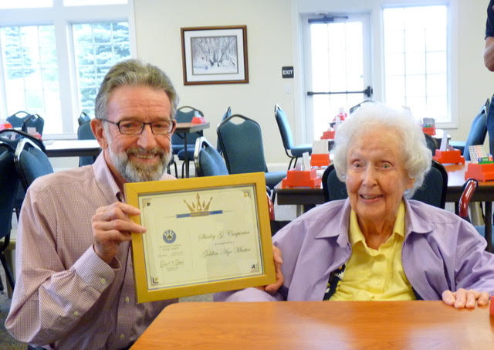
In Memoriam – We’re saddened to report that we’ve lost our dear friend Shirley Carpenter. We’re forever grateful to Shirley and her husband Jean who generously funded the majority of monies needed to build our current bridge house. The two of them loved to play bridge (not always as partners). They often traveled to a tournament by car on the spur of the moment, not having a place to stay nor partners to play with. Shirley is one of our Golden Age Masters. We will miss her. Our thoughts and prayers are with her family and friends.
Margaret Ruemenapp has also passed away. She was always ready to volunteer, and played regularly at the club for many years. Our thoughts and prayers are with her family and friends as well.

Find a Partner – Don’t forget that you can easily list yourself as needing a partner and look to see if any others have done so via the easy to use “Find a Partner” tab on our website.

ALERT! A reminder of our winter closing policy: we’re closed when North Central Michigan College Petoskey campus is closed.

