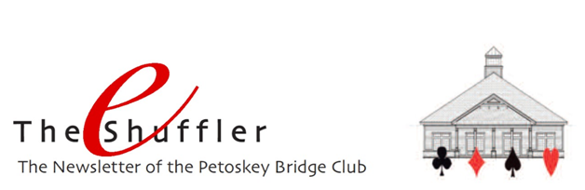

Greetings everyone. Here we are, early in the year, and it seems appropriate to do some updating, reminding, congratulating and thanking. So, here goes.

Keep the Game Moving - Duplicate bridge is a timed event. We all know that. There is a Round clock that tells us how much time remains in the round currently being played. The Director often tells us that we should be on our last board, or that there are 2 minutes remaining in the round. So for the overall enjoyment of all the players, it's important that each of us try our best to "play to the clock," and keep the game moving. There are a variety of simple things each of us can do to help:
- If you're on lead, confirm that that's the case and select your lead, placing it face down in front of you. Do this prior to handling the Bridgemate task (if you are N) and before entering the information into your personal scorecard.
- If you're sitting N and are Dummy, expose your hand as Dummy prior to entering the info into the Bridgemate or into your personal scorecard.
- Save any conversation you might want to have about a board until all boards in the round have been played. If time is available prior to the round being called, that would be the time to discuss any of the boards played that round. It would also be the time to visit the snack bar or rest room.
- If you do have time available in between rounds, do your best not to disrupt players who have yet to finish the round. Walk and speak softly so they can maintain their concentration and finish expeditiously.
Courtesy - And how about being kind and courteous to others, treating them like we would like to be treated. Let's do things like:
- Welcome players to your table at the beginning of each round
- Congratulate opponents for good play
- Refrain from giving "lessons" to your partner or to the opponents
- Do not gloat about achieving a good score
- Don't "snap" your cards as you play them, simply place or drop them on the table
And while we're at it, a couple other things to remember:
- Don't "play" with the bid box; determine your call and then go to the box and pull the appropriate card
- Don't make eye contact with your partner trying to be sure that he/she "got" your bid; that's called Unauthorized Information
Claims - Last month we addressed the issue of claims. It seems that that subject could use another shot in the arm as Claims continues to be an issue at the club. Here is part of the rule regarding claims:
A claim should be accompanied at once by a clear statement of the line of play or defense through which the claimer proposes to win the tricks claimed, including the order in which the cards will be played. The player making the claim or concession faces his hand.

So, if you are the player making the claim, please abide by this rule. And, if you are playing against one who makes the claim, and you disagree or are unclear, please call the Director immediately for clarity and resolution.

Rank Progression - Kudos to Les Achison and Carl Luepnitz. They both have moved up in rank to Junior Master. Congratulations!

2017 Ace of Clubs Masterpoint Race Winners - The ACBL has announced the winners of the races for masterpoints won at clubs in Unit 195. Congratulations to all, and especially to our Petoskey Bridge Club players!
​
- John Warzecha 3rd place in the 5-20 mps category
- Marlene Warzecha 4th place in the 5-20 mps category
- Gloria Ferris 4th place in the 20-50 mps category
- Jan Coltman 4th place in the 100-200 mps category
- Geoff Goldich 3rd place in the 500-1000 mps category
- Tom Beukema 4th place in the 1000-1500 mps category

Volunteers - We can't operate the club in the manner that we desire without lots of help. So, a big Thank You for all our volunteers, and in particular:
- LaVonne and Gary Reed who have for several years tirelessly taken on the responsibility for purchasing and stocking pop, snacks and paper products we all use and consume at the club.
- Nancy and Dave Fowler, and Patti and Balky Grannis for keeping our flower pots beautiful.
- Jeannette Aspenleiter and Janice Smolinski for graciously leading the Hospitality Committee, resulting in outstanding and fun events at the club.
- Bernadette Burkhardt for her never-ceasing efforts to always have a Rover available to partner with singles who come to play at the club.
- Arlene Loca, Sally Stump and Kathy Snyder who have taken the responsibility to ensure that Get Well and Sympathy cards are sent from all of us to our members in need.
In Memoriam - We're sad to have lost two wonderful members, Kathi Kan and Stephen Bartha. We're blessed to have had the opportunity to share a bit of their life.

