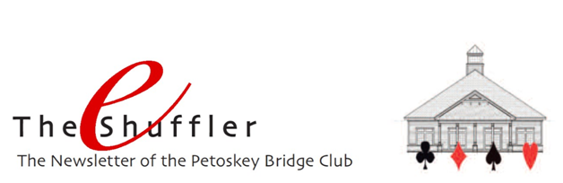

Happy New Year everyone. Hope you’ve had a wonderful holiday season with family and friends . . . and that you’re ready for another terrific year of bridge. Currently, our wintertime schedule offers games on Tuesday, Thursday and Friday, with the Friday Open section requiring registration. As the season progresses and snowbirds return, we’ll increase our game schedule accordingly by adding games on Sundays, Mondays, Wednesdays and Thursday evenings as we have in the past.
2019 Tournament Schedule – Since you might be working on your 2019 calendar, here are some tournaments to consider adding to it:
- May 9-11 Grand Rapids Sectional
- May 31-June 2 Kalamazoo Sectional
- June 23-24 Petoskey Sectional for Future Life Masters
- August 19-25 Grand Rapids Regional
- September 6-8 Traverse City Sectional
- September 27-29 Petoskey Sectional
Click HERE for a complete listing of the District 12 tournaments for 2019.

Rank Progression – Congratulations to Carol Bowman and Grace Ketchum who have recently become new Junior Masters!

Masterpoints – Speaking of rank progression, you might be interested to see your own masterpoint total. You can see it, as well as see where you rank versus all other ACBL members, by logging into your account on the ACBL website. Here’s how:
1. Go to ACBL.org
2. Click on MYACBL at the top
3. Log in or create an account (ACBL # and password)
4. Click on MASTERPOINTS on the left column

The rank number for each category shows how you rank in comparison with other active ACBL members in that category. The lower your rank number the better you are doing. The rank percentage shows how you rank as a comparison with every other active member in ACBL who also has points for that category. The higher your percentage the better you are doing.

Zero Tolerance Policy (repeated from last month) - The holiday season is also a good time to remember how fortunate we are to have such a great group of players who come to our beautiful facility to play an amazing game together.

In appreciation of each other, let’s remember to “maintain a courteous attitude at all times” and to “carefully avoid any remark or extraneous action that might cause annoyance or embarrassment to another player or might interfere with the enjoyment of the game.” ACBL Law 74.

And please don’t argue with the Director. The Director’s ruling is final, and play must continue without further discussion or comment. An appeal can be filed at the end of the game if further clarification is required. Remember, the Director is responsible for implementing ACBL’s Zero Tolerance policy and “is empowered to assess disciplinary penalties in points or to suspend a player for the current session or any part thereof.” ACBL Law 91.

Let’s all commit to making sure that the atmosphere at our club is one in which all players can have an enjoyable time together.

Mike Sears Sez – Last month we asked if there were any topics you’d like Mike to address. None came in, so Mike is taking the month off. Let us know if you have one you’d like him to tackle for next month.

Happy New Year!!!
And
Best Wishes for 2019

